Planning worksheet

Fullcast Holdout Policy Worksheet

Fullcast’s holdout policy allows you to specify rules for transitioning opportunities when account ownership changes. When a holdout is applied to a given opportunity, a lightning flag appears on the opportunity page layout. Additionally, a record is created in Fullcast’s Holdout custom object.
Opportunities are evaluated in this order: Exempt (dropped out), then Eligible (considered for holdout), then Ineligible (transferred immediately). Answer the following questions to prepare for configuring your holdout policy in Fullcast.

Exempt Opportunities
Identify opportunities that will NOT be considered for holdouts under the policy.

- Holdout Selection Criteria: What criteria make an opportunity exempt (excluded) from this policy, regardless of any other eligibility?
- Current and Outgoing Owner Must Match: Should this policy only apply if the Current and Outgoing Owner are the same user?

Eligible Opportunities
Identify opportunities that will be considered for holdouts under the policy.

- Holdout Selection Criteria: What criteria must an opportunity meet to be eligible for the automated holdout process?
- Holdout Restrictions (Optional): Do you need to limit the total number of holdout opportunities any single rep can possess at one time?
- Holdout Restrictions - Sort By and Order By (If Limited): How should the system Sort By and Order By opportunities to decide which ones are immediately transferred?

Participant Selection Period (Optional)
Determine whether to allow a period of time for account owners to select which opportunities to hold out.

- Participant Selection Period: Do you want to allow a “selection period” during which reps can select which opportunities they want to hold out?
- Selected Holdout Filtering: (If #6 is ON) What field (e.g., a checkbox) will the rep use to designate opportunities they want to keep?

Holdout Expiration
Determine when the holdout expires and what will happen to the holdout and opportunities when the expiration occurs.

- Holdout Expiration Timeframe: How long should the opportunity remain in the final holdout state? (in Days, Quarter, Half, Year)
- Expiration Action: What happens if the opportunity is still open when the holdout expires? (Select one: Assign to current account owner or Reassign to a specific role)

Updating Holdout Owners (Optional)
Designate ownership roles and members.

- Create Opportunity Team Members: Should the holdout owner be added as a member of the Opportunity Team?
- Team Role: If yes to above, what role should the new opportunity owner be given on the account team?

Updating Fields (Optional)
Specify which fields on the opportunity and holdout records to update, and what values to fill.

- Updating Fields: What fields on the holdout and/or opportunity records would you like to update? Choose from values on either the holdout, policy status, or opportunity records.

Opportunity Splits (Optional)
Choose whether to allocate opportunity splits between the outgoing and new owners. Percent splits between outgoing owner and new owner must add up to 100

- Hold Out Start: How is the split determined when the holdout begins? That is, if the deal closes during the holdout period
- Expiration/Transfer Split: How is the split determined when the holdout expires or transfers?
- Immediate Transfer Split: How is the split determined if the opportunity is immediately transferred (not held out)?

Ineligible Opportunities
- Account Ownership: What do you want to do with opportunities that end up being ineligible?
- Updating Holdout Owners: For holdouts, do you want to create an opportunity team member? If so, what role will the holdout owner have on the opportunity team?
- Updating Fields : List any Opportunity Fields that must be updated when this policy is applied.

Fallbacks & Defaults
- Select Default User: If something happens and we can’t transfer the opportunity to the person according to the policy, who should we transfer it to?
- Multiple Ownership Changes: If the account ends up changing hands after the holdout is created/starts, what do you want to do? (Keep existing holdout record OR overwrite the existing holdout.)

Example of Planning worksheet

EXAMPLE ✅ Holdout Policy Pre-Configuration Worksheet: Opportunity Management
Here is an example of a policy written out and how it would be configured in Fullcast.

Exempt Opportunities
Holdout Selection Criteria | What criteria make an opportunity exempt (excluded) from this policy, regardless of any other eligibility? | Renewals are exempt.
Current and Outgoing Owner Must Match | Should this policy only apply if the opportunity owner, current account owner and outgoing Owner are the same user? | Yes

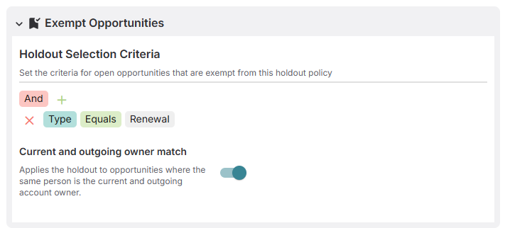

Eligible Opportunities
Holdout Selection Criteria | What criteria must an opportunity meet to be eligible for the automated holdout process? (Mandatory field.) | The opportunity type must not be a Renewal. The opportunity amount must be $50K or greater. The close date must be before June 30, 2026
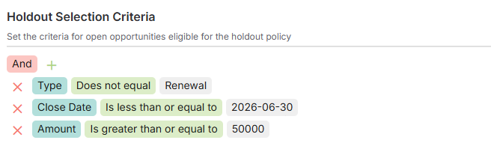

Holdout Restrictions
Holdout Restrictions | Do you need to limit the total number of holdout opportunities any single rep can possess at one time? | Yes, limit the total number of holdout opportunities to 10 per user.
Holdout Restrictions - Sort By and Order By | (If Limited) How should the system Sort and Order opportunities to decide which ones are immediately transferred? | The system should sort by the Opportunity Amount. The order should be the smallest value opportunity will be transferred first.
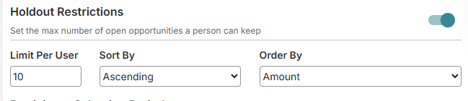

Participant Selection Period
Participant Selection Period | Do you want to use a rep-driven interim selection period before applying the final holdout? | Yes, a rep-driven interim selection period will be used. The period will last for seven days.
Selected Holdout Filtering | (If Period is ON) What field (e.g., a checkbox) will the rep use to designate opportunities they want to keep? | The rep will use the custom checkbox field called Keep Opportunity. The value for selection will be True.
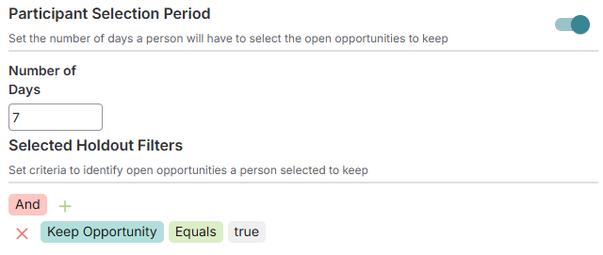

Holdout Expiration
Holdout Expiration Timeframe | How long should the opportunity remain in the final holdout state? (in Days, Quarter, Half, Year) | The opportunity should remain in the final holdout state for forty-five days.
Expiration Action | What happens if the opportunity is still open when the holdout expires? (Select one)  Assign to current account owner or Reassign to a specific role? | When the holdout expires, the opportunity should be assigned to the Current Account Owner.
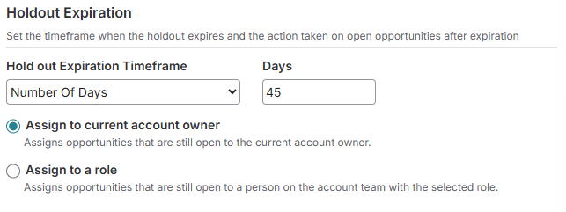

Updating Holdout Owners
Create Opportunity Team Members | Should the holdout owner be added as a member of the Opportunity Team? If | Yes, the holdout owner should be added to the Opportunity Team.
Team Role | If yes to above, what role should the new oppty owner be | Account Executive

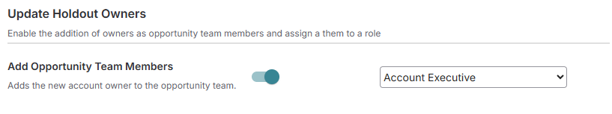

Update Fields (Optional)
Update Fields | Which fields on the opportunity to update, and what values to fill. | Update the opportunity status to indicate that it is currently in a holdout.
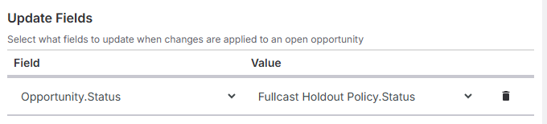

Opportunity Splits
 |  | Current Owner | New owner
Hold Out Start | How is the split determined when the holdout begins? That is, if the deal closes during the holdout period | 90 | 10
Expiration/Transfer Split | How is the split determined when the holdout expires or transfers? | 25 | 75
Immediate Transfer Split | How is the split determined if the opportunity is immediately transferred (not held out)? | 10 | 90
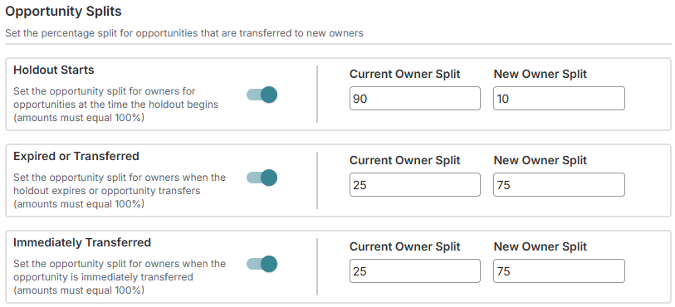

Ineligible Opportunities
Account Ownership | What do you want to do with opportunities that end up being ineligible? | Assign to the Account Executive on the Account Team
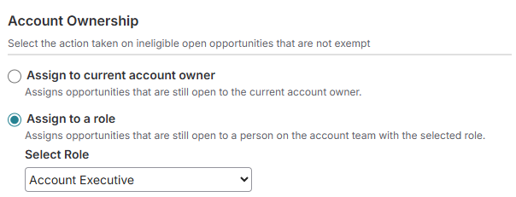
Updating Holdout Owners | For holdouts, do you want to create an opportunity team member? If so, what role will the holdout owner have on the oppty team?
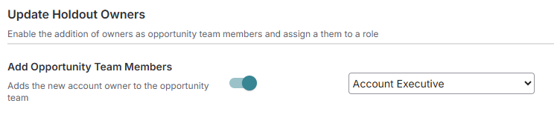
Updating Fields | List any Opportunity Fields that must be updated when this policy is applied. | Don’t update any fields on opportunities that don’t get holdouts.
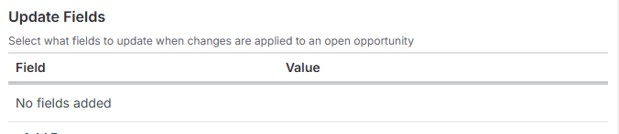

Fallbacks & Defaults
Select Default User | If something happens and we can’t figure out who we’re supposed to transfer the oppty to, who should we transfer it to? | Integration User
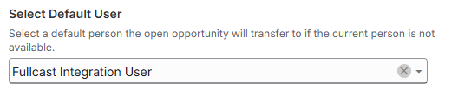
Multiple ownership changes | If the account ends up changing hands after the holdout is created/starts, what do you want to do? | Keep the existing holdout
